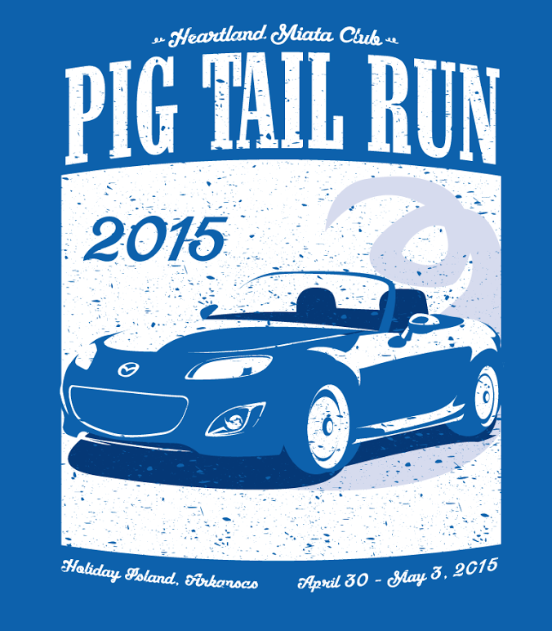

**Come Drive With Us!**

**Miles of Smiles We Bankroll Into Memories**

**www.heartlandmiata.com**

**DEADLINE: APRIL 1, 2015**

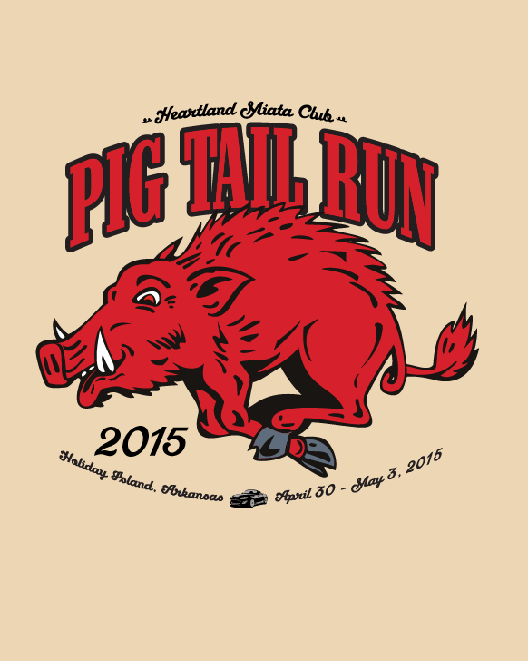

**GAME PLAN**

Thursday Night: Winery Tour

Friday: 3 Runs Planned

Friday Night: ‘Meet N’ Greet’/ Dine & BYOB (Food Provided/BYOB) Driver’s Meeting/Sign Up for Drives

Saturday: 3 Drives Planned

Saturday Night Dinner in Town ***(You MUST RSVP with HMC for reservations!***)

Parking designated for our Miatas.

Car washing stations be avail with buckets and rags (bring your own soap!)

Questions: [tooiresh@hotmail.com](mailto:tooiresh@hotmail.com) 816-838-8559

For More Information: tooiresh@hotmail.com

***Mark Your Calendars*** 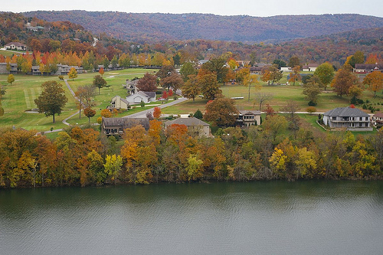

Holiday Island, AR

***April 30tht- May 3rd: 2015***

Welcome! ***The Heartland Miata Club of Greater Kansas City*** is hosting Our 1st Pig Tail Run.

This event will be held in Holiday Island, Arkansas which is approximately 6 miles from Eureka Springs, AR.

Arrangements have been made @

**Island Motel & Resort;**

[1-800-874-1331](tel:1-800-874-1331) (Under Heartland Miata Club of Greater KC)

<http://www.holidayislandlodging.com/accommodations-view.html?ID=41>

**Cost**: Rooms; $54.95 or $59.95 per night (depending on size)

Condos avail to rent!

Make Your Own Reservations!

OVERFLOW: Eureka Springs!

**Event Registration Fee:** $15 per Miata

**Meet & Greet Fee** (Includes Food): $10 per person **BYOB**